Day82 - Task40 - Kubernetes(Part-04)

Task 1: Deploy an Application with a Deployment (3 Replicas, RollingUpdate Strategy)

Step 1: Understand What a Deployment Adds Over a ReplicaSet
A Deployment does not manage pods directly. It manages a ReplicaSet, and that ReplicaSet manages the pods, the same relationship the ReplicaSet has with its pods in the earlier lab. What the Deployment adds is a recorded rollout history and an update strategy, so changing the pod template (for example, a new image tag) produces a controlled transition to a new ReplicaSet instead of an immediate, uncontrolled replacement of every pod.

Step 2: Create the Deployment
The block below is a single shell command: everything between cat <<EOF and the closing EOF is sent to ‘kubectl apply’ as YAML. Copy and paste the whole block at once, keeping the indentation exactly as shown and using spaces only (no tabs). The strategy block is written out explicitly even though RollingUpdate with these values is also the default, so the configuration is visible in the manifest.
cat <<EOF | kubectl apply -f -
apiVersion: apps/v1
kind: Deployment
metadata:
name: webapp-deploy
spec:
replicas: 3
selector:
matchLabels:
app: webapp-deploy
strategy:
type: RollingUpdate
rollingUpdate:
maxSurge: 25%
maxUnavailable: 25%
template:
metadata:
labels:
app: webapp-deploy
spec:
containers:
- name: nginx
image: nginx:1.25
ports:
- containerPort: 80
EOF

Terminal output showing deployment.apps/webapp-deploy created
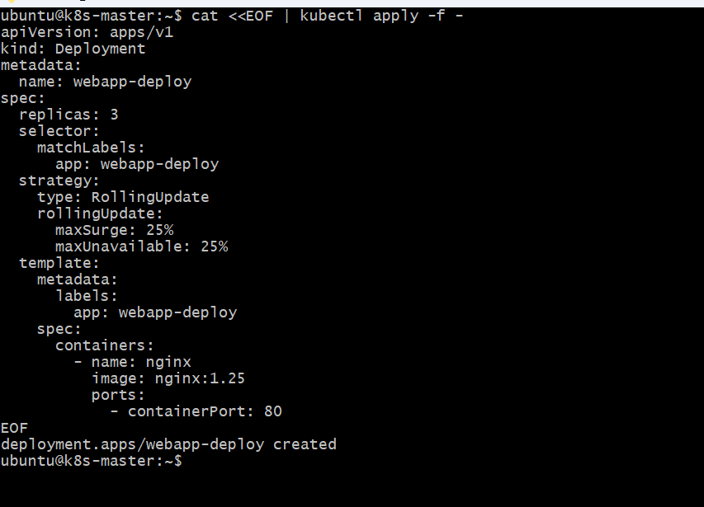

Step 3: Verify the Deployment, ReplicaSet, and Pods
List all three objects in the chain. The Deployment and the ReplicaSet it owns should both show three desired and three ready, and the pods should be Running with names of the form webapp-deploy-<replicaset-hash>-<pod-suffix>.
kubectl get deployment webapp-deploy
kubectl get rs -l app=webapp-deploy
kubectl get pods -l app=webapp-deploy -o wide
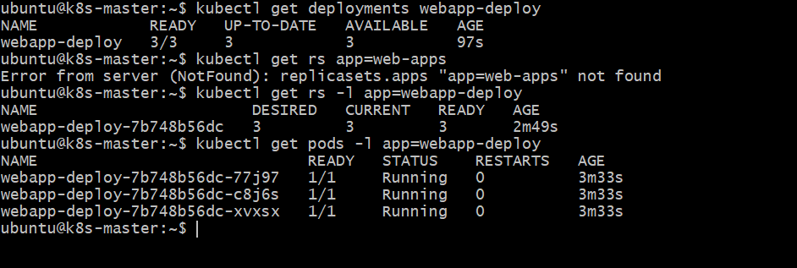
Terminal output showing webapp-deploy with 3/3 READY, its ReplicaSet with DESIRED 3 CURRENT 3 READY 3, and three webapp-deploy pods Running
Step 4: Check the Rollout Status and Strategy
kubectl rollout status blocks until the Deployment finishes rolling out (it should return immediately here since nothing is changing), and describe confirms the strategy type and the surge/unavailable values that were set.
kubectl rollout status deployment/webapp-deploy
kubectl describe deployment webapp-deploy | grep -A3 StrategyType

Terminal output showing "deployment \"webapp-deploy\" successfully rolled out" and StrategyType: RollingUpdate with RollingUpdateStrategy 25% max unavailable, 25% max surge
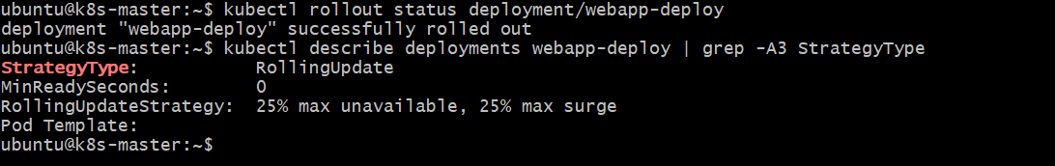
Validation Steps
- kubectl get deployment webapp-deploy shows 3/3 under READY and UP-TO-DATE and AVAILABLE both 3.
- kubectl get rs -l app=webapp-deploy shows exactly one ReplicaSet with DESIRED 3, CURRENT 3, READY 3.
- kubectl get pods -l app=webapp-deploy lists three pods, all STATUS Running.
- kubectl describe deployment webapp-deploy reports StrategyType: RollingUpdate with the configured surge and unavailable values.

Task 2: Configure a Deployment with a Recreate Strategy and Observe the Downtime

Step 1: Create the Deployment with the Recreate Strategy
The Recreate strategy takes no rollingUpdate parameters — there is nothing to tune, because the whole point of this strategy is that old and new pods are never meant to run at the same time.
cat <<EOF | kubectl apply -f -
apiVersion: apps/v1
kind: Deployment
metadata:
name: webapp-recreate
spec:
replicas: 3
selector:
matchLabels:
app: webapp-recreate
strategy:
type: Recreate
template:
metadata:
labels:
app: webapp-recreate
spec:
containers:
- name: nginx
image: nginx:1.24
ports:
- containerPort: 80
EOF
Terminal output showing deployment.apps/webapp-recreate created
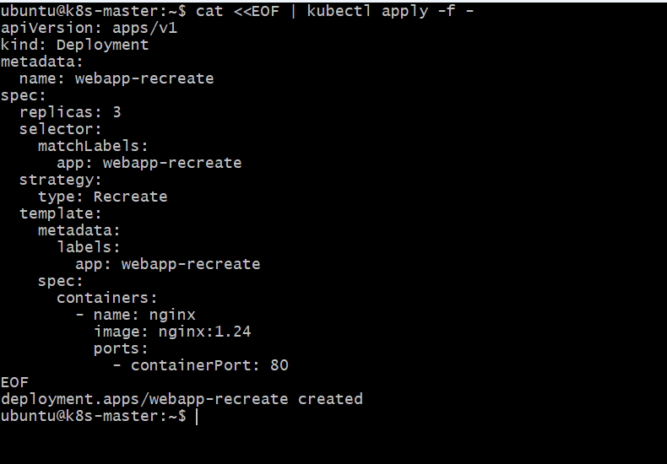
Step 2: Expose the Deployment and Confirm It Is Healthy
A ClusterIP Service gives a stable address to probe during the update. Confirm all three pods are Running before moving on.
kubectl expose deployment webapp-recreate --name=webapp-recreate-svc --port=80 --target-port=80
kubectl get deployment webapp-recreate
kubectl get pods -l app=webapp-recreate -o wide
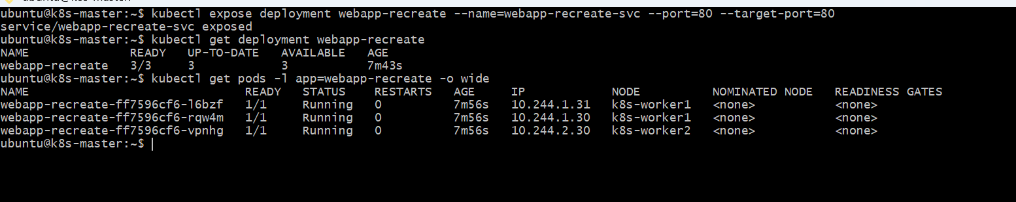
Terminal output showing webapp-recreate-svc created and webapp-recreate at 3/3 READY with three Running pods
Step 3: Start a Background Probe Against the Service
Run a tight curl loop against the Service in the background, writing one line per request so the gap in successful responses can be seen afterwards. This must be started before the update in Step 4.
CLUSTERIP=$(kubectl get svc webapp-recreate-svc -o jsonpath="{.spec.clusterIP}")
(for i in $(seq 1 60); do
curl -s -o /dev/null -w "%{http_code}\n" --max-time 1 http://$CLUSTERIP
sleep 0.5
done) > /tmp/recreate-probe.log &

Terminal output showing the background probe loop started
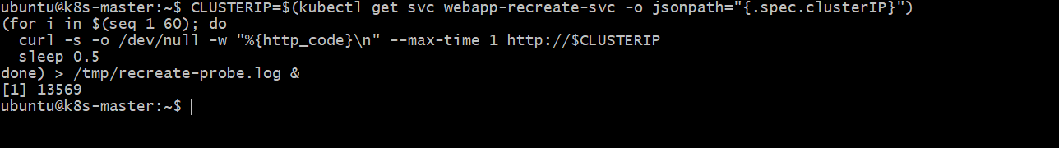

Step 4: Trigger the Update and Watch the Pods
Change the image tag and immediately watch the pods. With Recreate, all three old pods move to Terminating together, and no new pod is created until the old ones are gone, so there is a moment with zero Running pods for this Deployment.
kubectl set image deployment/webapp-recreate nginx=nginx:1.25
kubectl get pods -l app=webapp-recreate -w

Terminal output of the watch showing all three old pods Terminating together, a period with no Running pods, then three new pods appearing and turning Running
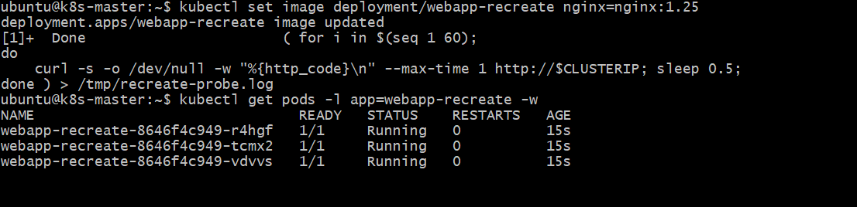

Step 5: Read Back the Probe Log
Stop and inspect the log from Step 3. A run of non-200 codes (000 for connection refused/timed out, or empty lines) in the middle of the log is the downtime window; requests before and after it succeed.
wait
cat /tmp/recreate-probe.log
grep -c '^200$' /tmp/recreate-probe.log
grep -vc '^200$' /tmp/recreate-probe.log

Terminal output of the probe log showing a contiguous block of failed (non-200) results surrounded by successful 200 results, and the two counts confirming how many requests failed
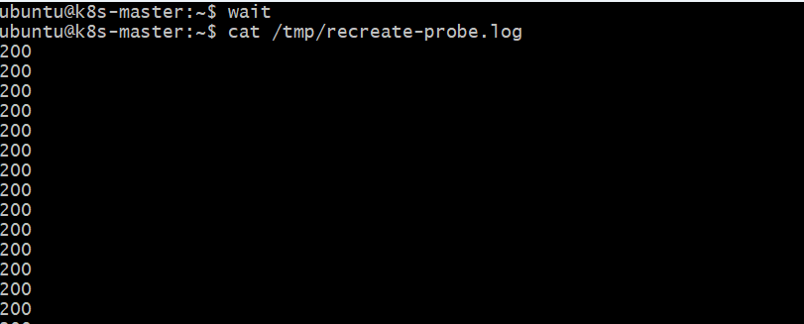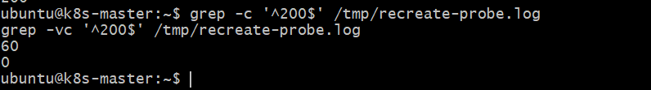

Validation Steps
- kubectl get deployment webapp-recreate shows StrategyType: Recreate in kubectl describe.
- During the update, kubectl get pods -l app=webapp-recreate -w shows a period where zero pods for this Deployment are Running.
- The background probe log contains a contiguous run of failed requests between successful ones.
- After the rollout completes, kubectl get deployment webapp-recreate returns to 3/3 READY running nginx:1.25.

Task 3: Update an Existing Deployment and Perform a Rollback to the Previous Version

Step 1: Record the Current Revision
Before changing anything, record webapp-deploy's rollout history and annotate the current revision so it is easy to identify by its change-cause later.
kubectl annotate deployment webapp-deploy kubernetes.io/change-cause="Initial rollout: nginx:1.25" --overwrite
kubectl rollout history deployment/webapp-deploy

Terminal output showing the rollout history with revision 1 and its change-cause
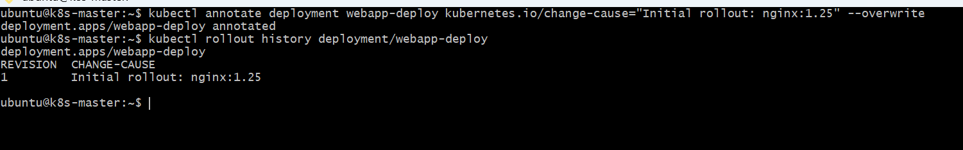
Step 2: Update to an Image Tag That Does Not Exist
Set the image to a tag that Docker Hub does not have. kubectl records this as revision 2 and starts a rolling update, but the new pods will never become ready.
kubectl set image deployment/webapp-deploy nginx=nginx:1.99-broken
kubectl annotate deployment webapp-deploy kubernetes.io/change-cause="Bad update: nginx:1.99-broken" --overwrite
kubectl rollout status deployment/webapp-deploy --timeout=30s

Terminal output showing the rollout status command timing out or reporting the rollout has not finished

Step 3: Confirm the Failure
List the pods and describe one of the new ones. Because maxUnavailable is 25%, the Deployment keeps most of the old, working pods running rather than tearing them all down for a template that cannot start — this is the safety RollingUpdate provides over Recreate.
kubectl get pods -l app=webapp-deploy
kubectl describe deployment webapp-deploy | grep -A5 Conditions
kubectl rollout history deployment/webapp-deploy

Terminal output showing at least one pod in ImagePullBackOff or ErrImagePull, old nginx:1.25 pods still Running, and revision 2 listed in the rollout history
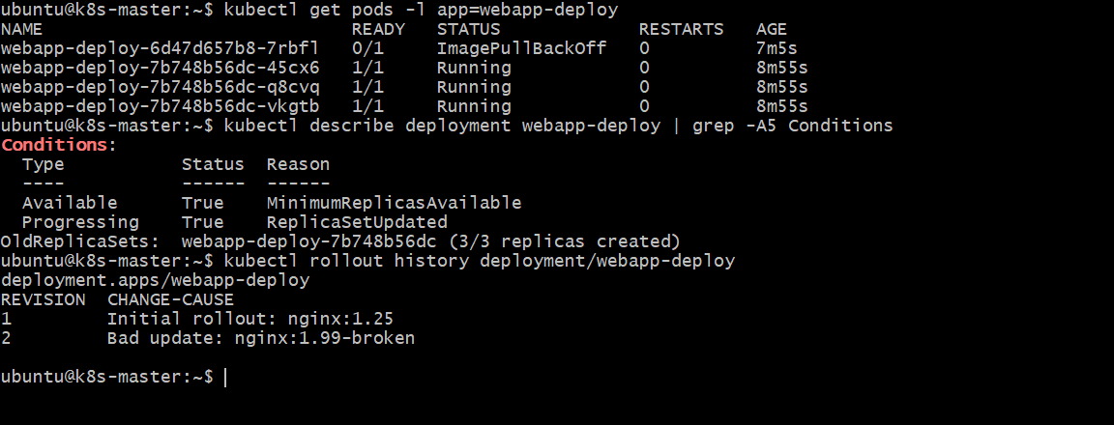

Step 4: Roll Back to the Previous Revision
kubectl rollout undo reverts the Deployment's pod template to the previous revision recorded in its history, which starts a normal rolling update back to nginx:1.25.
kubectl rollout undo deployment/webapp-deploy
kubectl rollout status deployment/webapp-deploy
Terminal output showing the rollback command accepted and "deployment \"webapp-deploy\" successfully rolled out"
Step 5: Verify the Rollback
Confirm every pod is back on nginx:1.25 and Running, and that the rollout history now shows a new revision created by the undo.

kubectl rollout history deployment/webapp-deploy

Terminal output listing three pods all on nginx:1.25, and the rollout history showing the revision created by the undo
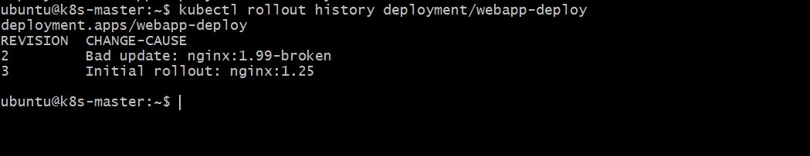

Validation Steps
- After Step 2, kubectl get pods -l app=webapp-deploy shows at least one pod in ImagePullBackOff/ErrImagePull.
- kubectl rollout history deployment/webapp-deploy lists the bad update as a distinct revision with its change-cause.
- kubectl rollout undo deployment/webapp-deploy reports the rollback and rollout status confirms success.
- All three webapp-deploy pods run nginx:1.25 and are Running after the rollback.

Task 4: Modify a Deployment to Add Resource Requests and Limits for CPU and Memory

Step 1: Check the Current Pod Spec Has No Resource Section
Confirm the container spec does not yet define requests or limits, so the effect of this task is easy to see.
kubectl get deployment webapp-deploy -o jsonpath="{.spec.template.spec.containers[0].resources}"; echo

Terminal output showing an empty object ({}) for the current resources field

Step 2: Understand the Fields Being Added
Flag / Field | What It Means (Beginner Explanation)
requests.cpu | The amount of CPU the scheduler reserves for this container when choosing a node. Set to 100m (0.1 of a CPU core).
requests.memory | The amount of memory reserved at scheduling time. Set to 128Mi.
limits.cpu | The hard ceiling on CPU the container may use; the kernel throttles it beyond this. Set to 250m.
limits.memory | The hard ceiling on memory; exceeding it gets the container OOMKilled. Set to 256Mi.

Step 3: Patch the Deployment
kubectl patch with a strategic merge updates just the container's resources field, leaving everything else in the template untouched. Changing the pod template is itself a template change, so it triggers a normal RollingUpdate rollout exactly like changing the image did in Task 3.
cat <<EOF > /tmp/webapp-resources-patch.yaml
spec:
template:
spec:
containers:
- name: nginx
resources:
requests:
cpu: "100m"
memory: "128Mi"
limits:
cpu: "250m"
memory: "256Mi"
EOF
kubectl patch deployment webapp-deploy --patch-file /tmp/webapp-resources-patch.yaml
kubectl rollout status deployment/webapp-deploy

Terminal output showing deployment.apps/webapp-deploy patched and the rollout completing successfully
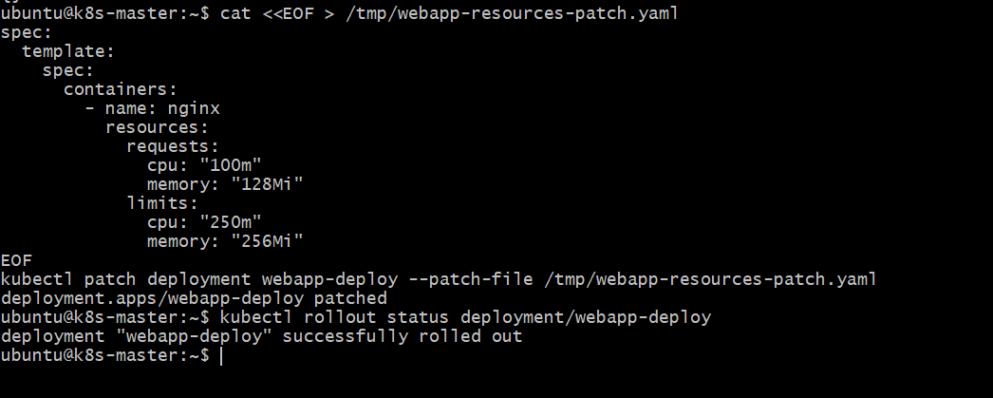

Step 4: Verify the Resources on a Pod
Describe one of the new pods and confirm the Requests and Limits sections match what was patched in.
POD=$(kubectl get pods -l app=webapp-deploy -o jsonpath="{.items[0].metadata.name}")
kubectl describe pod $POD | grep -A6 Requests

Terminal output showing cpu: 100m, memory: 128Mi under Requests and cpu: 250m, memory: 256Mi under Limits
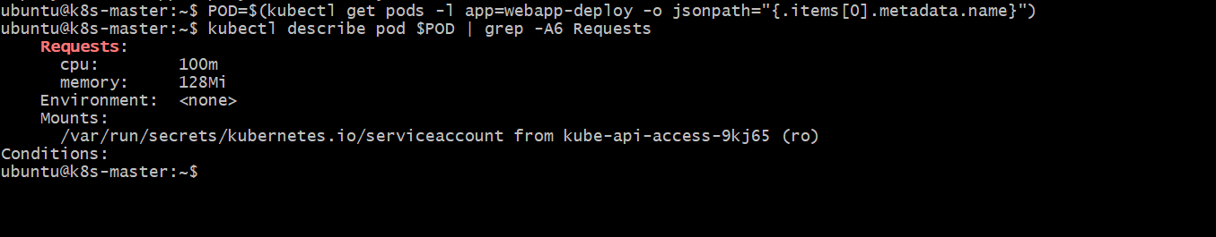

Step 5: Confirm the Nodes Reflect the New Allocation
Every node the pods landed on should now show these requests counted against it in the Allocated resources section.

Terminal output of kubectl describe node showing the webapp-deploy pods listed with their CPU and memory requests, and the node's totals including them
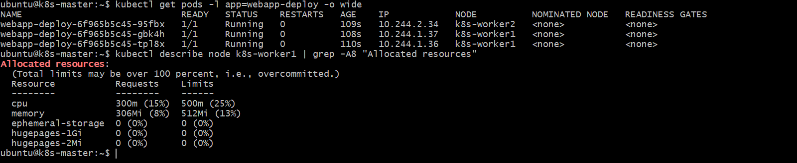

Validation Steps
- kubectl get deployment webapp-deploy -o jsonpath shows the patched resources object before rollout finishes.
- kubectl rollout status deployment/webapp-deploy reports success after the patch.
- kubectl describe pod on any webapp-deploy pod shows Requests cpu=100m/memory=128Mi and Limits cpu=250m/memory=256Mi.
- kubectl describe node on each node running a webapp-deploy pod lists it under Allocated resources with the matching request values.

Task 5: Create a Deployment with MaxSurge and MaxUnavailable Configurations

Step 1: Understand maxSurge and maxUnavailable
Flag / Field | What It Means (Beginner Explanation)
maxSurge: 2 | During a rollout, up to 2 pods above the desired count (6) may exist at once, so the total can briefly reach 8.
maxUnavailable: 1 | During a rollout, at most 1 of the desired 6 pods may be unavailable at once, so at least 5 must always be ready.

Step 2: Create the Deployment
cat <<EOF | kubectl apply -f -
apiVersion: apps/v1
kind: Deployment
metadata:
name: webapp-surge
spec:
replicas: 6
selector:
matchLabels:
app: webapp-surge
strategy:
type: RollingUpdate
rollingUpdate:
maxSurge: 2
maxUnavailable: 1
template:
metadata:
labels:
app: webapp-surge
spec:
containers:
- name: nginx
image: nginx:1.24
ports:
- containerPort: 80
EOF
kubectl rollout status deployment/webapp-surge

Terminal output showing deployment.apps/webapp-surge created and successfully rolled out with 6/6 READY
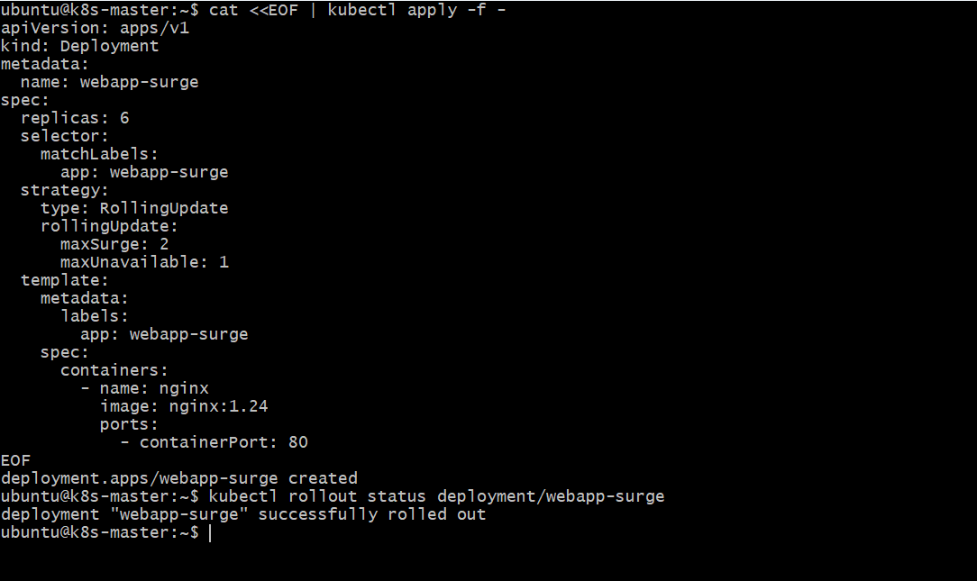

Step 3: Confirm the Baseline
kubectl get deployment webapp-surge
kubectl get pods -l app=webapp-surge -o wide
Terminal output showing webapp-surge at 6/6 READY with six Running pods
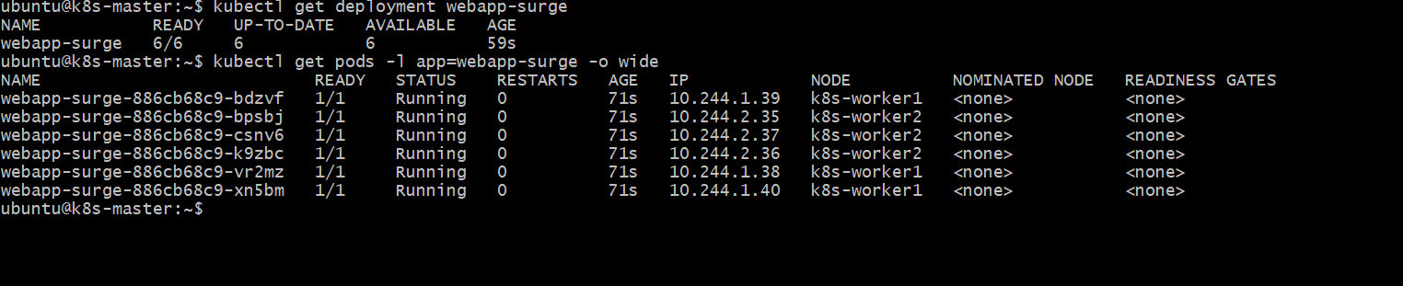

Step 4: Trigger an Update and Watch the Counts
Change the image tag and immediately poll the Deployment repeatedly. During the rollout, watch the total pod count (DESIRED + surge column, up to 8) and the READY count (which should never drop below 5).
kubectl set image deployment/webapp-surge nginx=nginx:1.25
for i in $(seq 1 20); do
echo "--- $(date +%T) ---"
kubectl get pods -l app=webapp-surge --no-headers | wc -l
kubectl get pods -l app=webapp-surge --no-headers | grep -c Running
sleep 1
done

Terminal output of the loop showing the total pod count rising to at most 8 and the Running/Ready count never dropping below 5 during the rollout
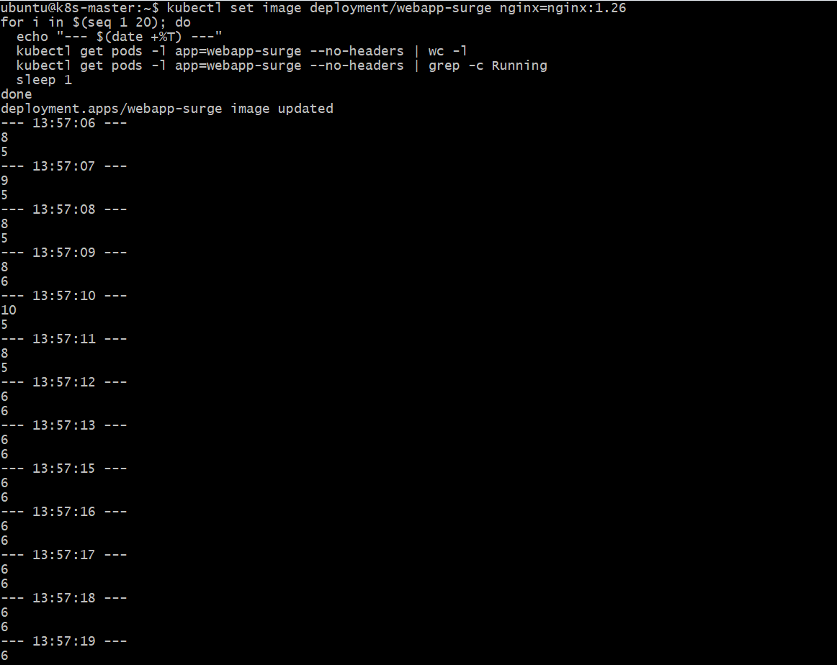

Step 5: Confirm the Final State
kubectl rollout status deployment/webapp-surge
kubectl get pods -l app=webapp-surge -o jsonpath="{range .items[*]}{.metadata.name}{'\t'}{.spec.containers[0].image}{'\n'}{end}"

Terminal output showing the rollout completed and all six pods running nginx:1.25
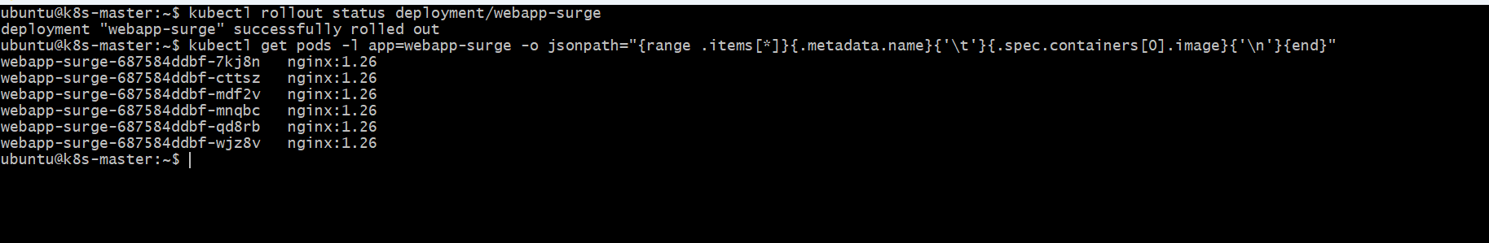

Validation Steps
- kubectl describe deployment webapp-surge shows RollingUpdateStrategy: 1 max unavailable, 2 max surge.
- During the rollout, the total number of webapp-surge pods observed at any point does not exceed 8 (6 + maxSurge).
- During the rollout, the number of Running/Ready webapp-surge pods observed at any point does not drop below 5 (6 − maxUnavailable).
- After the rollout, kubectl get deployment webapp-surge shows 6/6 READY on nginx:1.25.

Task 6: Set Up a Deployment with a Custom Revision History Limit

Step 1: Create the Deployment with a Custom History Limit

cat <<EOF | kubectl apply -f -
apiVersion: apps/v1
kind: Deployment
metadata:
name: webapp-history
spec:
replicas: 3
revisionHistoryLimit: 2
selector:
matchLabels:
app: webapp-history
template:
metadata:
labels:
app: webapp-history
spec:
containers:
- name: nginx
image: nginx:1.22
ports:
- containerPort: 80
EOF
kubectl annotate deployment webapp-history kubernetes.io/change-cause="v1: nginx:1.22" --overwrite
kubectl rollout status deployment/webapp-history
Terminal output showing deployment.apps/webapp-history created and rolled out with revisionHistoryLimit: 2 set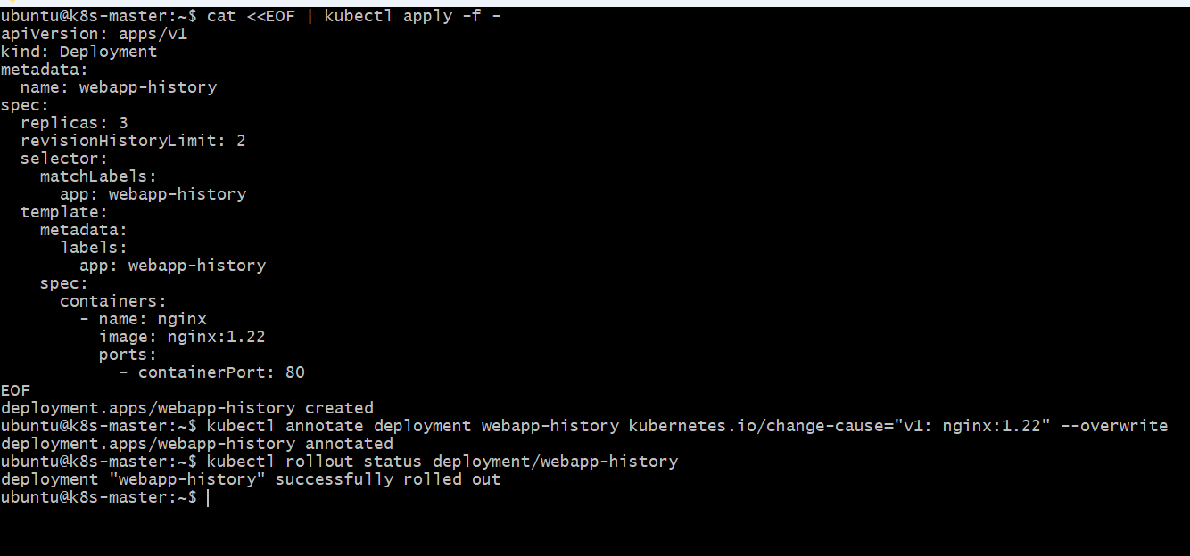

Step 2: Perform Three Successive Updates
Each update creates a new revision and a new ReplicaSet, and scales the previous ReplicaSet to zero without deleting it — until the count of retained old ReplicaSets exceeds revisionHistoryLimit.
kubectl set image deployment/webapp-history nginx=nginx:1.23
kubectl annotate deployment webapp-history kubernetes.io/change-cause="v2: nginx:1.23" --overwrite
kubectl rollout status deployment/webapp-history

kubectl set image deployment/webapp-history nginx=nginx:1.24
kubectl annotate deployment webapp-history kubernetes.io/change-cause="v3: nginx:1.24" --overwrite
kubectl rollout status deployment/webapp-history

kubectl set image deployment/webapp-history nginx=nginx:1.25
kubectl annotate deployment webapp-history kubernetes.io/change-cause="v4: nginx:1.25" --overwrite
kubectl rollout status deployment/webapp-history

Terminal output showing all three rollouts (to nginx:1.23, nginx:1.24, and nginx:1.25) completing successfully
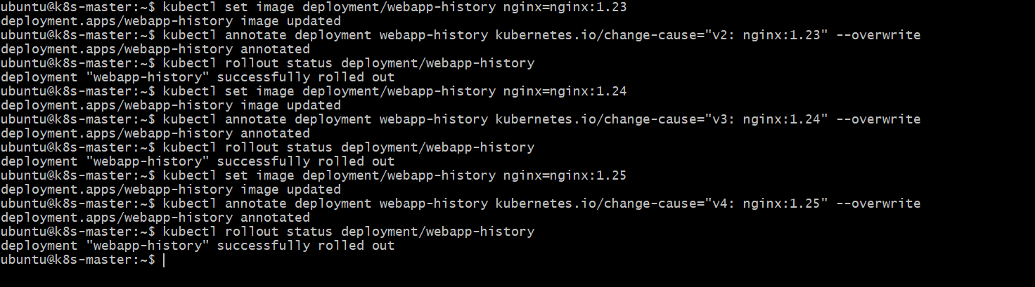
Step 3: List the ReplicaSets
Four ReplicaSets were created in total (the original plus three updates), but only the current one plus revisionHistoryLimit old ones — two here — should remain.
kubectl get rs -l app=webapp-history

Terminal output listing three ReplicaSets total for webapp-history: one with 3 current pods and two scaled to 0, with the oldest ReplicaSet (for nginx:1.22) no longer present
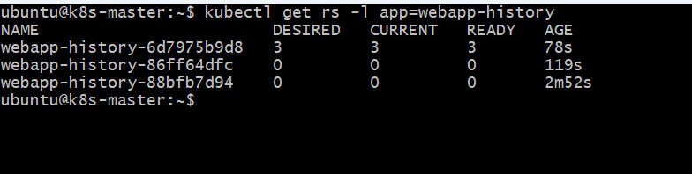

Step 4: Compare Against the Rollout History
kubectl rollout history deployment/webapp-history

Terminal output of the rollout history showing only the retained revisions with their change-cause annotations, with the oldest (v1) no longer listed
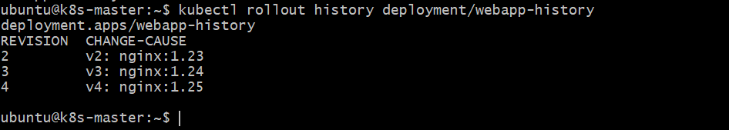
Validation Steps
- kubectl get deployment webapp-history -o jsonpath="{.spec.revisionHistoryLimit}" returns 2.
- After three updates, kubectl get rs -l app=webapp-history lists at most three ReplicaSets (one current plus two retained old ones).
- The ReplicaSet for the original nginx:1.22 template is no longer present once a fourth revision exists.
- kubectl rollout history deployment/webapp-history no longer lists the earliest (v1) change-cause once it has been pruned.

Task 7: Pause a Deployment During an Update, and Then Resume It

Step 1: Confirm the Starting State
kubectl get deployment webapp-deploy
kubectl get pods -l app=webapp-deploy -o wide

Terminal output showing webapp-deploy at 3/3 READY before the update
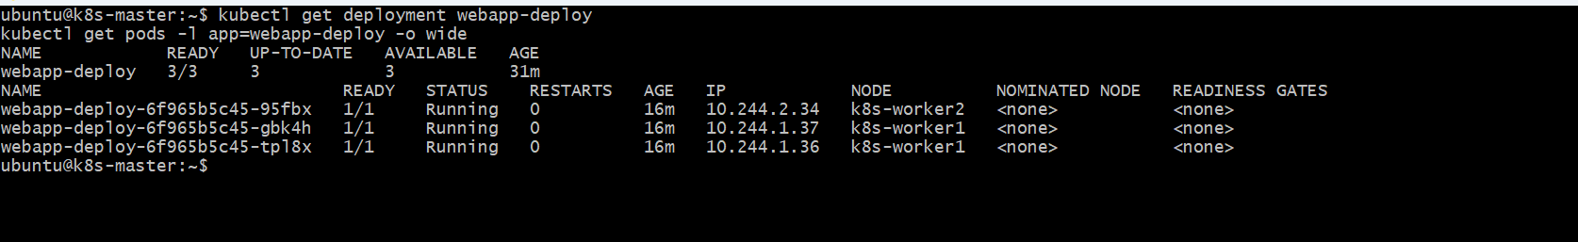
Step 2: Trigger an Update and Pause Immediately
Change the image and pause the Deployment right away. Because maxUnavailable/maxSurge are percentages of only three replicas, this step may need to be repeated once or twice to catch the rollout before it finishes; watch for a mix of old and new pods after pausing.

kubectl set image deployment/webapp-deploy nginx=nginx:1.27
kubectl rollout pause deployment/webapp-deploy
kubectl get pods -l app=webapp-deploy -o jsonpath="{range .items[*]}{.metadata.name}{'\t'}{.spec.containers[0].image}{'\n'}{end}"

Terminal output showing kubectl rollout pause accepted, and the pod list showing a mix of pods still on nginx:1.25 and pods already on nginx:1.27
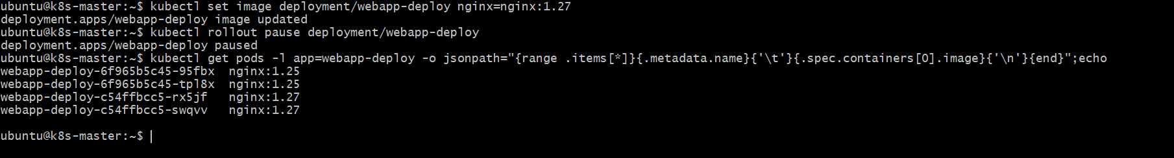

Step 3: Confirm the Rollout Is Stalled
rollout status should hang rather than report success, and the ReplicaSets should show the rollout frozen partway between the old and new revision.
kubectl rollout status deployment/webapp-deploy --timeout=15s
kubectl get rs -l app=webapp-deploy

Terminal output showing rollout status timing out, and kubectl get rs showing both the old and new ReplicaSet with non-zero pod counts
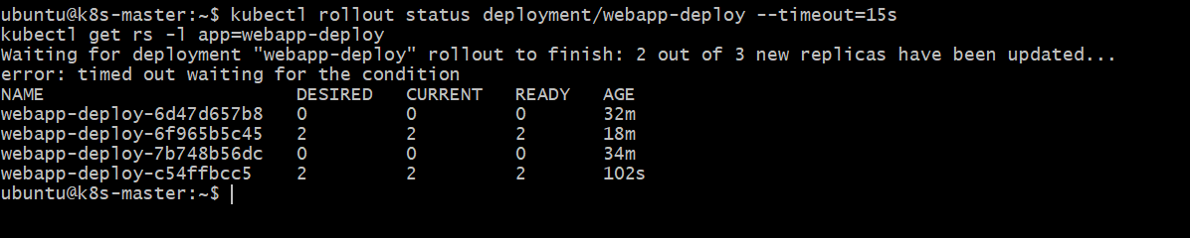

Step 4: Make a Second Change While Paused
While a Deployment is paused, further changes to its template update the object immediately but are not rolled out to pods until it is resumed. This lets multiple edits be batched into a single rollout instead of triggering one rollout per change.
kubectl set resources deployment/webapp-deploy -c=nginx --limits=cpu=300m,memory=300Mi
kubectl get pods -l app=webapp-deploy -o jsonpath="{range .items[*]}{.metadata.name}{'\t'}{.spec.containers[0].image}{'\n'}{end}"

Terminal output showing the resource limits command accepted while paused, and the pod list unchanged from Step 2 — proving the second change has not been rolled out yet
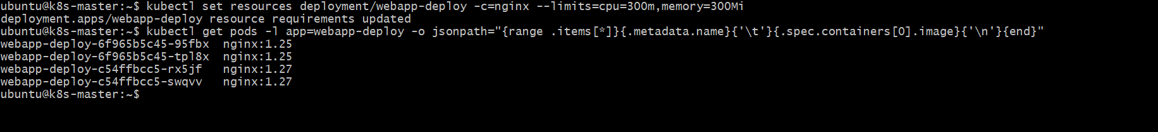
Step 5: Resume the Rollout
kubectl rollout resume lets the Deployment continue reconciling. Both the image update from Step 2 and the resource change from Step 4 are applied together in the remainder of the rollout.
kubectl rollout resume deployment/webapp-deploy
kubectl rollout status deployment/webapp-deploy

Terminal output showing kubectl rollout resume accepted and "deployment \"webapp-deploy\" successfully rolled out"
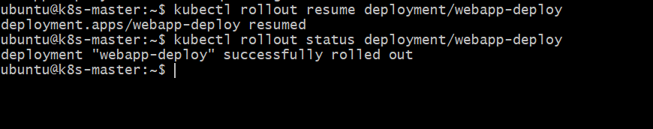

Step 6: Verify the Final State
kubectl get pods -l app=webapp-deploy -o jsonpath="{range .items[*]}{.metadata.name}{'\t'}{.spec.containers[0].image}{'\n'}{end}"
kubectl describe pod $(kubectl get pods -l app=webapp-deploy -o jsonpath="{.items[0].metadata.name}") | grep -A6 Limits

Terminal output showing all three pods on nginx:1.27 and the new resource limits (cpu: 300m, memory: 300Mi) applied
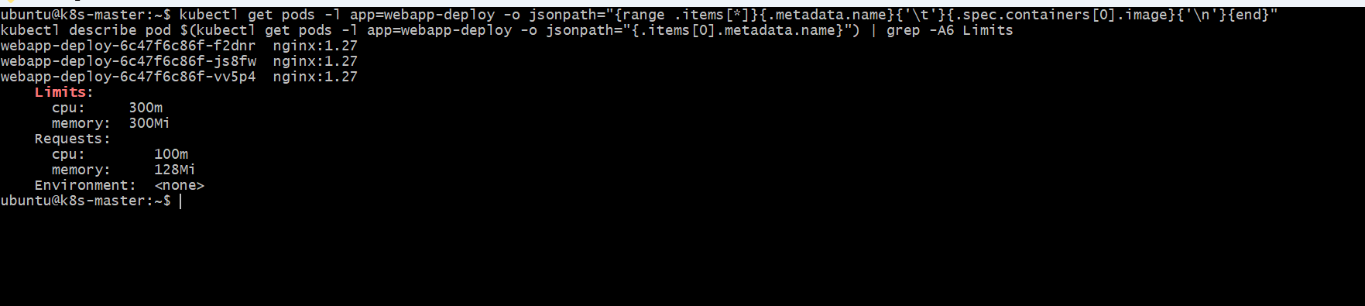
Validation Steps
- kubectl rollout pause deployment/webapp-deploy is accepted while pods still show a mix of old and new images.
- kubectl rollout status reports no progress (times out) while the Deployment is paused.
- A second change made while paused (the resource limits) does not appear on any pod until resume is issued.
- After kubectl rollout resume, the rollout completes and every pod reflects both the image and resource changes.

Task 8: Create a Pod with Resource Requests and Observe Scheduler Placement

Step 1: Record Allocatable Capacity and Current Allocation on Each Node
Before creating the pod, capture a baseline. The Allocated resources section of describe node shows both the totals reserved so far and the percentage of the node's allocatable capacity that represents.
kubectl get nodes -o wide
for n in $(kubectl get nodes -o jsonpath="{.items[*].metadata.name}"); do
echo "=== $n ==="
kubectl describe node $n | grep -A2 "Allocatable:"
kubectl describe node $n | grep -A8 "Allocated resources"
done

Terminal output showing each node's allocatable CPU/memory and current allocated totals before the new pod is created
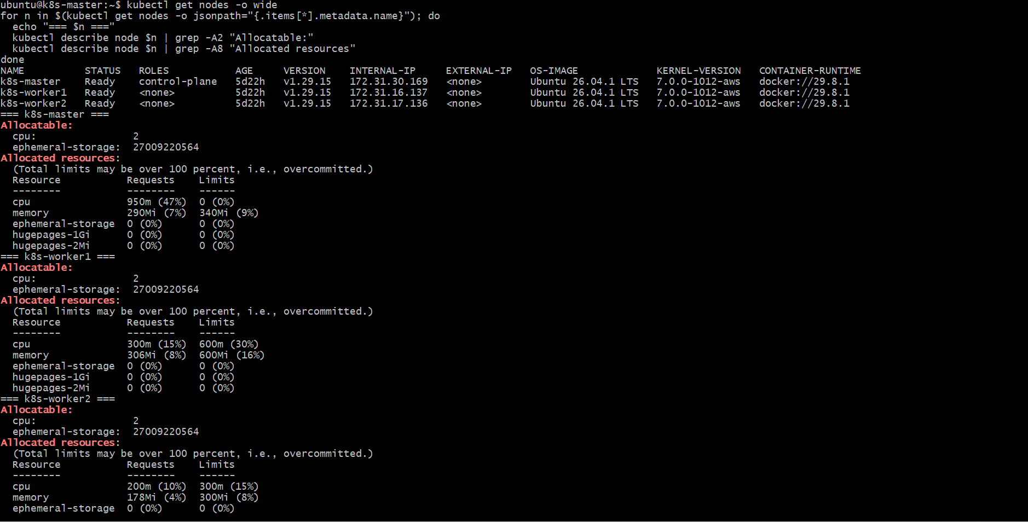

Step 2: Create the Pod with Resource Requests
cat <<EOF | kubectl apply -f -
apiVersion: v1
kind: Pod
metadata:
name: resource-pod
labels:
app: resource-pod
spec:
containers:
- name: nginx
image: nginx:latest
resources:
requests:
cpu: "500m"
memory: "256Mi"
limits:
cpu: "1"
memory: "512Mi"
ports:
- containerPort: 80
EOF

Terminal output showing pod/resource-pod created
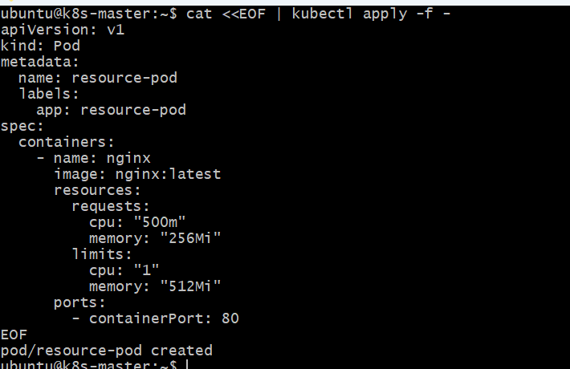

Step 3: Identify the Node the Scheduler Chose
kubectl get pod resource-pod -o wide

Terminal output of kubectl get pod -o wide showing resource-pod Running with its assigned NODE
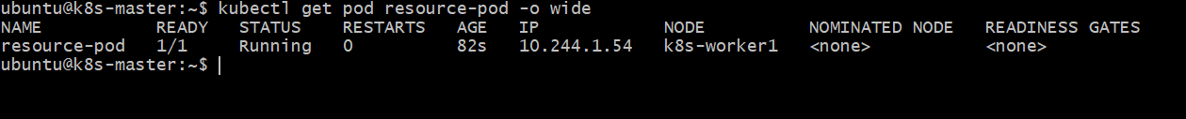

Step 4: Read the Scheduling Decision from the Pod's Events
The Events section of describe pod records the exact moment and node the default scheduler chose.
kubectl describe pod resource-pod | grep -A10 Events
kubectl describe pod resource-pod | grep -A6 Requests

Terminal output showing a Scheduled event naming the chosen node, and the pod's Requests matching cpu: 500m, memory: 256Mi
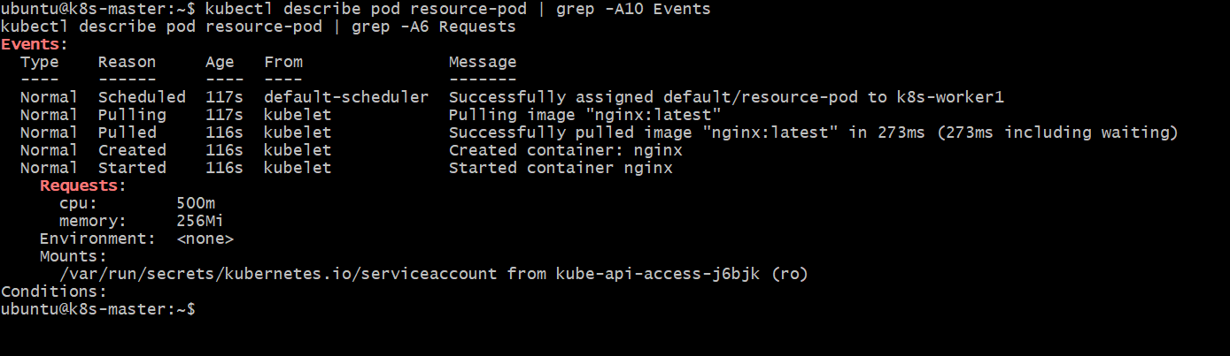

Step 5: Confirm the Node's Allocated Resources Increased
Re-check only the node that received the pod. Its Allocated resources total for CPU and memory should now be higher than the baseline from Step 1 by exactly the pod's requests, and resource-pod should be listed among the pods counted there.
NODE=$(kubectl get pod resource-pod -o jsonpath="{.spec.nodeName}")
kubectl describe node $NODE | grep -A10 "Allocated resources"

Terminal output showing resource-pod listed under the chosen node's Allocated resources, with the CPU and memory totals increased over the Step 1 baseline
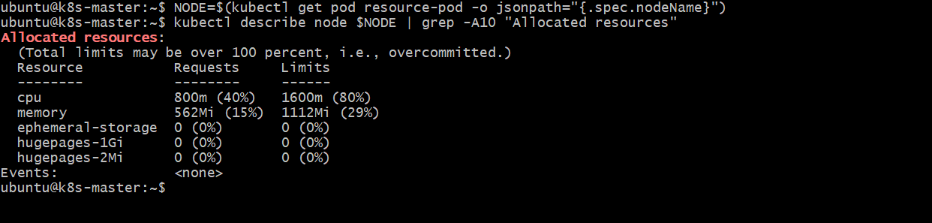

Validation Steps
- kubectl get pod resource-pod -o wide shows STATUS Running with a NODE assigned.
- kubectl describe pod resource-pod shows a Scheduled event and Requests of cpu=500m, memory=256Mi.
- The node named in the Scheduled event is one of the two worker nodes recorded in the Step 1 baseline.
- That node's Allocated resources total, re-checked in Step 5, is higher than its Step 1 baseline by the pod's requested amounts.

